1.

OUTPUT:

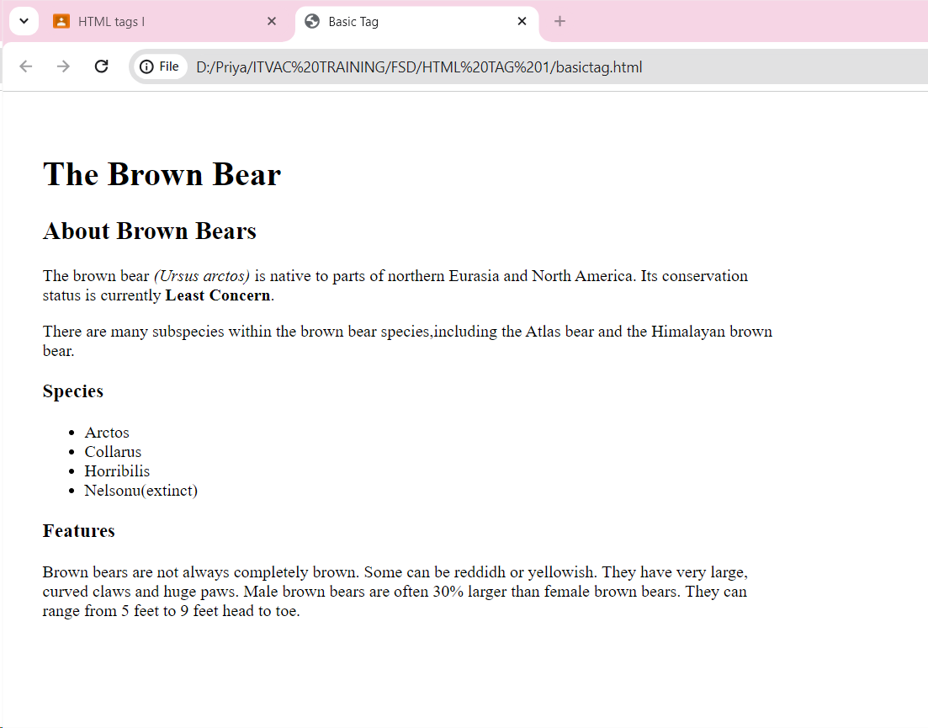

CODE:

<!DOCTYPE html>

<html lang="en">

<head>

<meta charset="UTF-8">

<meta name="viewport" content="width=device-width, initial-scale=1.0">

<title>Basic Tag</title>

<style>

body

{

padding: 30px;

width:700px;

}

</style>

</head>

<body>

<h1>The Brown Bear</h1>

<h2>About Brown Bears</h2>

<p>The brown bear <i>(Ursus arctos)</i> is native to parts of northern Eurasia and North America. Its conservation status is currently <b>Least Concern</b>.</p>

<p>There are many subspecies within the brown bear species,including the Atlas bear and the Himalayan brown bear.</p>

<h3>Species</h3>

<ul>

<li>Arctos</li>

<li>Collarus</li>

<li>Horribilis</li>

<li>Nelsonu(extinct)</li>

</ul>

<h3>Features</h3>

<p>Brown bears are not always completely brown. Some can be reddidh or yellowish. They have very large, curved claws and huge paws. Male brown bears are often 30% larger than female brown bears. They can range from 5 feet to 9 feet head to toe.</p>

</body>

</html>

2.

OUTPUT:

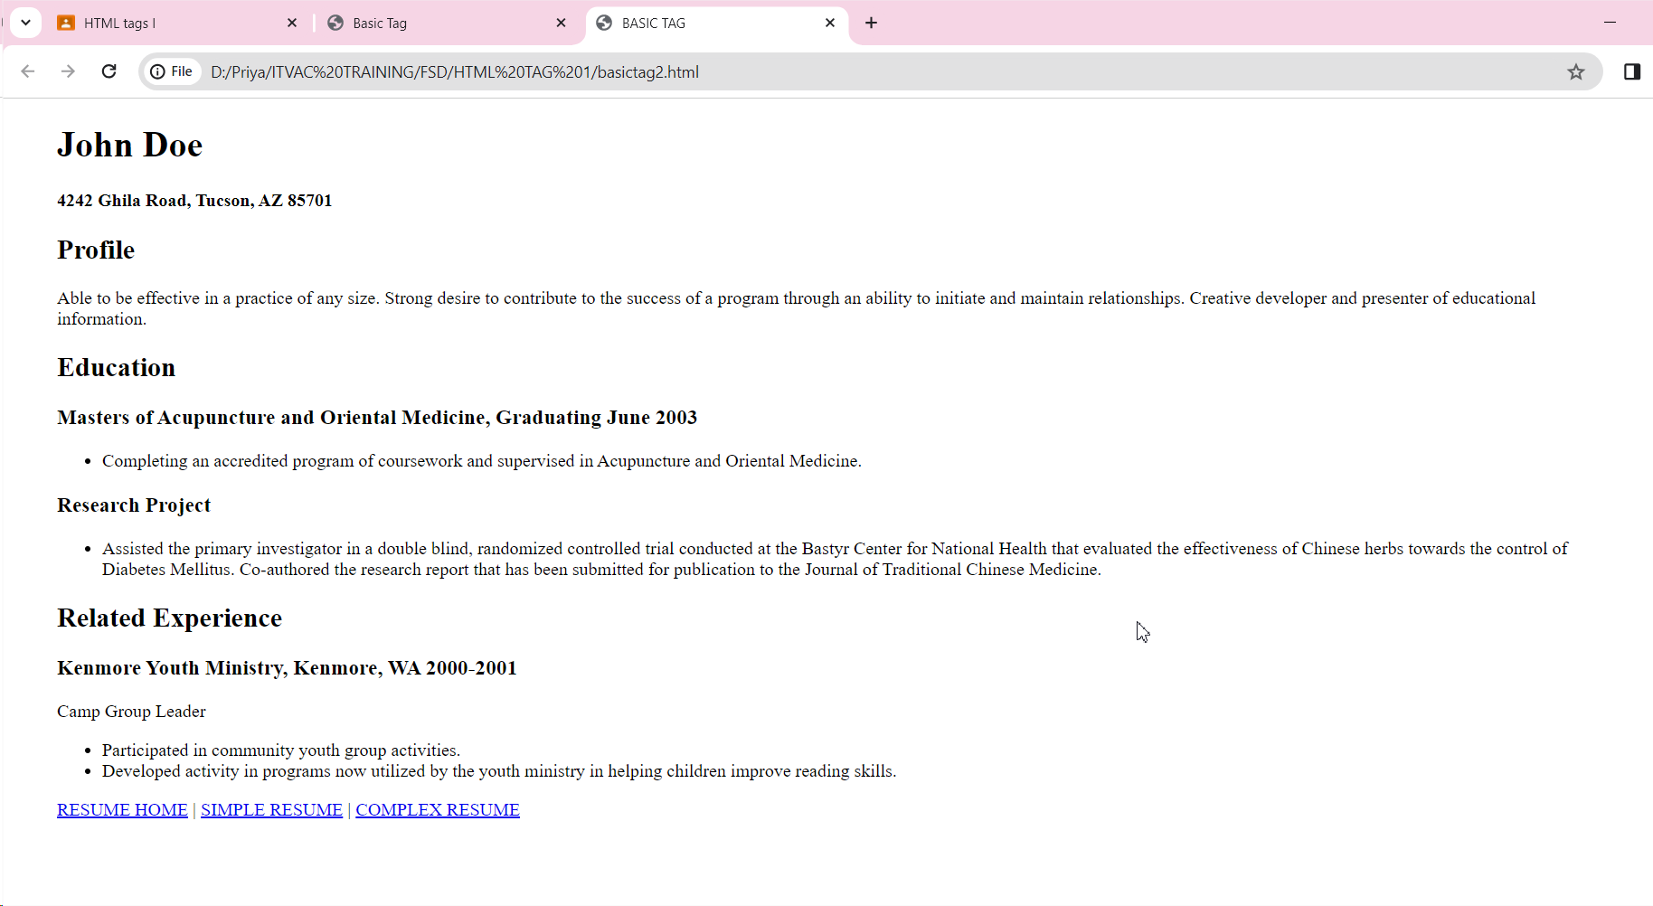

CODE:

<!DOCTYPE html>

<html lang="en">

<head>

<meta charset="UTF-8">

<meta name="viewport" content="width=device-width, initial-scale=1.0">

<title>BASIC TAG</title>

<style>

body{

padding-left:40px;

padding-right:40px;

width: 1350px;

}

</style>

</head>

<body>

<h1>John Doe</h1>

<h4>4242 Ghila Road, Tucson, AZ 85701</h4>

<h2>Profile</h2>

<p>Able to be effective in a practice of any size. Strong desire to contribute to the success of a program through an ability to initiate and maintain relationships. Creative developer and presenter of educational information.</p>

<h2>Education</h2>

<h3>Masters of Acupuncture and Oriental Medicine, Graduating June 2003</h3>

<ul>

<li>Completing an accredited program of coursework and supervised in Acupuncture and Oriental Medicine.</li>

</ul>

<h3>Research Project</h3>

<ul>

<li>Assisted the primary investigator in a double blind, randomized controlled trial conducted at the Bastyr Center for National Health that evaluated the effectiveness of Chinese herbs towards the control of Diabetes Mellitus. Co-authored the research report that has been submitted for publication to the Journal of Traditional Chinese Medicine.</li>

</ul>

<h2>Related Experience</h2>

<h3>Kenmore Youth Ministry, Kenmore, WA 2000-2001</h3>

<P>Camp Group Leader</P>

<ul>

<li>Participated in community youth group activities.</li>

<li>Developed activity in programs now utilized by the youth ministry in helping children improve reading skills.</li>

</ul>

<p><a href="#">RESUME HOME</a> | <a href="#">SIMPLE RESUME</a> | <a href ="#">COMPLEX RESUME</a></p>

</body>

</html>

3.

OUTPUT:

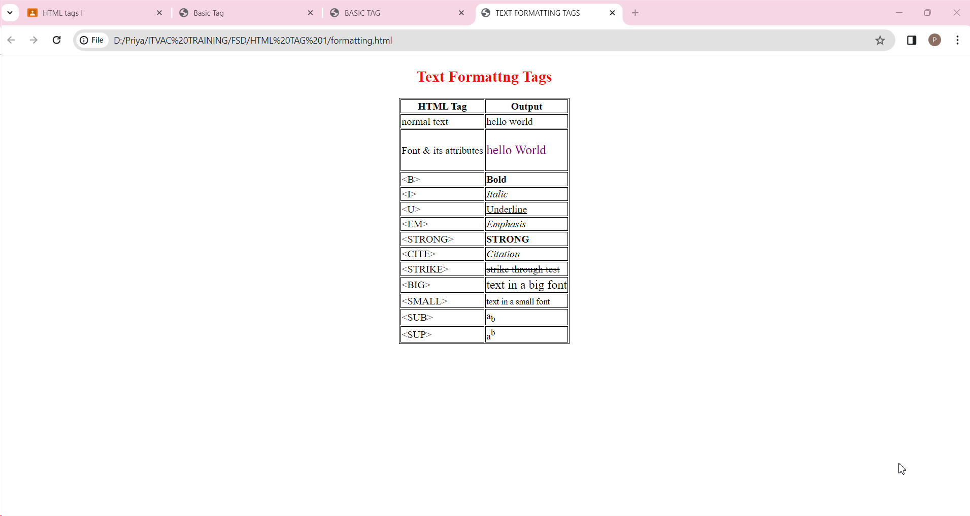

CODE:

<!DOCTYPE html>

<html lang="en">

<head>

<meta charset="UTF-8">

<meta name="viewport" content="width=device-width, initial-scale=1.0">

<title>TEXT FORMATTING TAGS</title>

<style>

.clr{

color:purple;

font-size:20px;

}

table,td,th{

border:1px solid black;

}

h2

{

color:red;

}

</style>

</head>

<body>

<center>

<h2>Text Formattng Tags</h2>

<table>

<tr>

<th>HTML Tag</th>

<th>Output</th>

</tr>

<tr>

<td>normal text</td>

<td>hello world</td>

</tr>

<tr>

<td>Font & its attributes</td>

<td><p class="clr">hello World</p></td>

</tr>

<tr>

<td>&lt;B&gt;</pre></td>

<td><b>Bold</b></td>

</tr>

<tr>

<td>&lt;I&gt;</td>

<td><i>Italic</i></td>

</tr>

<tr>

<td>&lt;U&gt;</td>

<td><u>Underline</u></td>

</tr>

<tr>

<td>&lt;EM&gt;</td>

<td><em>Emphasis</em></td>

</tr>

<tr>

<td>&lt;STRONG&gt;</td>

<td><strong>STRONG</strong></td>

</tr>

<tr>

<td>&lt;CITE&gt;</td>

<td><cite>Citation</cite></td>

</tr>

<tr>

<td>&lt;STRIKE&gt;</td>

<td><strike>strike through test</strike></td>

</tr>

<tr>

<td>&lt;BIG&gt;</td>

<td><big>text in a big font</big></td>

</tr>

<tr>

<td>&lt;SMALL&gt;</td>

<td><small>text in a small font</small></td>

</tr>

<tr>

<td>&lt;SUB&gt;</td>

<td>a<sub>b</sub></td>

</tr>

<tr>

<td>&lt;SUP&gt;</td>

<td>a<sup>b</sup></td>

</tr>

</table>

</center>

</body>

</html>

4.

OUTPUT:

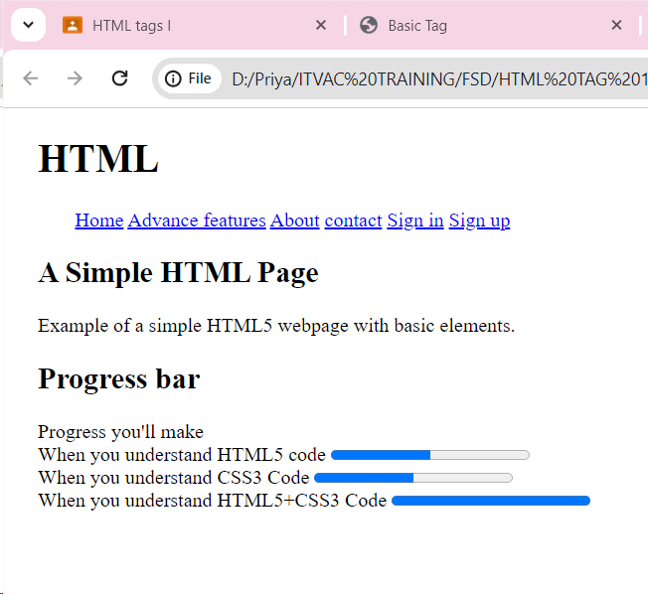

CODE:

<!DOCTYPE html>

<html lang="en">

<head>

<meta charset="UTF-8">

<meta name="viewport" content="width=device-width, initial-scale=1.0">

<title>HTML</title>

<style>

.space

{

padding-left: 30px;

}

body

{

padding-left: 20px;

}

</style>

</head>

<body>

<h1>HTML</h1>

<p class="space"><a href="#">Home</a> <a href="#">Advance features</a> <a href="#">About</a> <a href="#">contact</a> <a href="#">Sign in</a> <a href="#">Sign up</a></p>

<h2>A Simple HTML Page</h2>

<p>Example of a simple HTML5 webpage with basic elements.</p>

<h2>Progress bar</h2>

<p>Progress you'll make<br/>

When you understand HTML5 code <progress value="50" max="100"></progress><br/>

When you understand CSS3 Code <progress value="50" max="100"></progress><br/>

When you understand HTML5+CSS3 Code <progress value="10" max="10"></progress></p>

</body>

</html>

5.

OUTPUT:

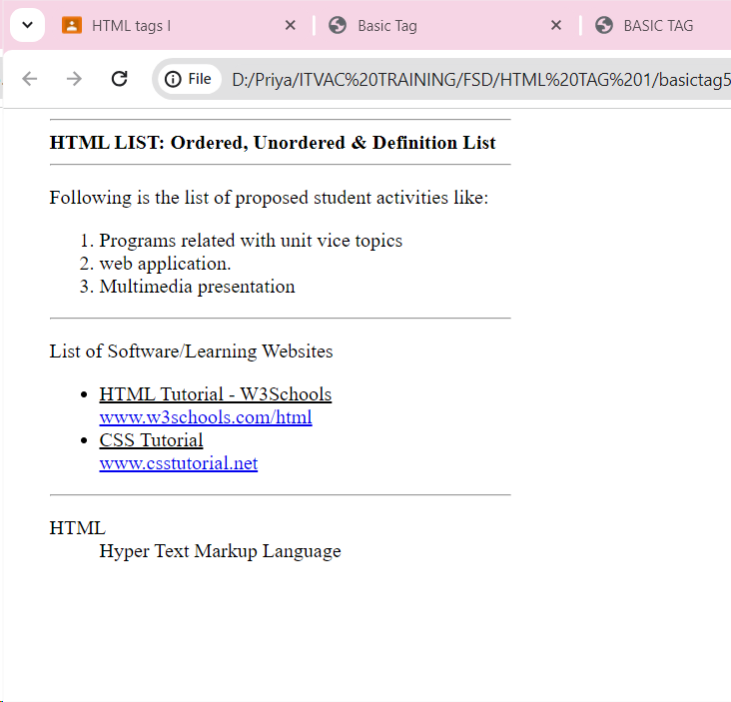

CODE:

<!DOCTYPE html>

<html lang="en">

<head>

<meta charset="UTF-8">

<meta name="viewport" content="width=device-width, initial-scale=1.0">

<title>HTML LIST</title>

<style>

.box

{

padding-left: 30px;

}

body

{

width: 400px;

}

</style>

</head>

<body>

<div class="box">

<hr>

<b>HTML LIST: Ordered, Unordered & Definition List</b>

<hr>

<p>Following is the list of proposed student activities like:</p>

<ol>

<li>Programs related with unit vice topics</li>

<li>web application.</li>

<li>Multimedia presentation</li>

</ol>

<hr/>

<p>List of Software/Learning Websites</p>

<ul>

<li><u>HTML Tutorial - W3Schools</u><br/><a href="#">www.w3schools.com/html</a></li>

<li><u>CSS Tutorial</u><br/><a href="#">www.csstutorial.net</a></li>

</ul>

<hr>

<dl>

<dt>HTML</dt>

<dd>Hyper Text Markup Language</dd>

</dl>

</div>

</body>

</html>

6.

OUTPUT:

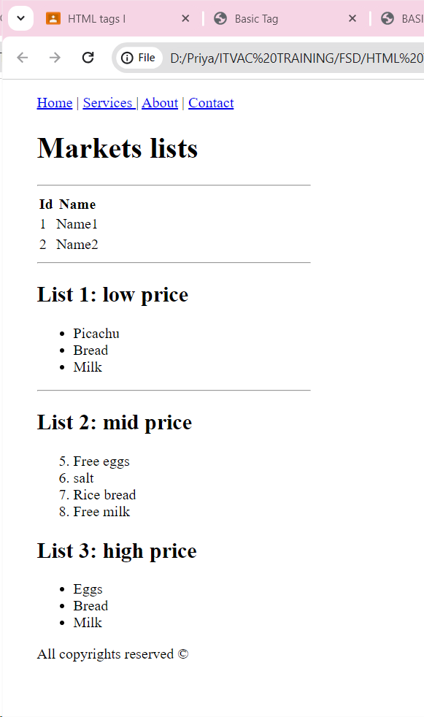

CODE:

<!DOCTYPE html>

<html lang="en">

<head>

<meta charset="UTF-8">

<meta name="viewport" content="width=device-width, initial-scale=1.0">

<title>List 2</title>

<style>

body{

width: 300px;

padding-left: 30px;

}

</style>

</head>

<body>

<div>

<p><a href="#">Home</a> | <a href="#">Services </a> | <a href="#">About</a> | <a href="#">Contact</a></p>

<h1>Markets lists</h1>

<hr>

<table>

<tr>

<th>Id</th>

<th>Name</th>

</tr>

<tr>

<td>1</td>

<td>Name1</td>

</tr>

<tr>

<td>2</td>

<td>Name2</td>

</tr>

</table>

<hr/>

<h2>List 1: low price</h2>

<ul>

<li>Picachu</li>

<li>Bread</li>

<li>Milk</li>

</ul>

<hr/>

<h2>List 2: mid price</h2>

<ol start="5">

<li>Free eggs</li>

<li>salt</li>

<li>Rice bread</li>

<li>Free milk</li>

</ol>

<h2>List 3: high price</h2>

<ul>

<li>Eggs</li>

<li>Bread</li>

<li>Milk</li>

</ul>

</div>

<span>All copyrights reserved &copy;</span>

</body>

</html>